The VBA of Wall Street

Vijitha Samarasinghe

Stock Market Analyst:

2014

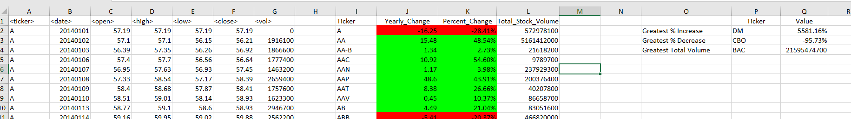

2015

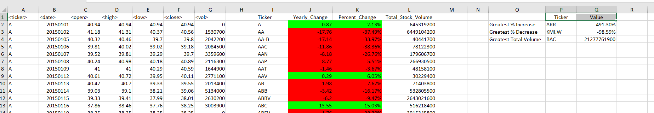

2016

